Fall 2013 INCOL Workshop – Treasures of Inland History at the Washington State Archives: Digital Archives*

Join us for this unique opportunity to learn about the inner workings and treasured collections of the Washington State Archives - Digital Archives on Wednesday, November 13th, 2013.
Located in Cheney on the Eastern Washington University campus, the Digital Archives is the nation's first archive dedicated specifically to the preservation of electronic records from both state and local agencies which have permanent legal, fiscal or historical value. We’ll learn about their holdings, take a tour, and navigate the Archives’ website. This unique and important Inland Northwest information resource is sure to have relevance to all INCOL libraries and patrons.
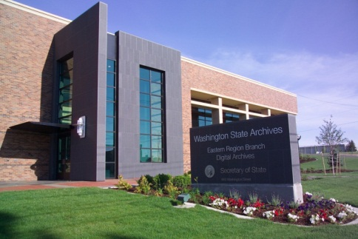
Washington State Archives · Digital Archives
960 Washington Street, Cheney WA 99004
(509) 235-7500

Select either a morning session or afternoon session:

Morning Session  Registration: 9:00 am – 9:30 am  Workshop: 9:30 am – 12:00 pm | Afternoon Session  Registration: 1:30 pm -2:00 pm  Workshop: 2:00 pm – 4:30 pm

Registration information:
• There is no registration fee for employees of INCOL member libraries
• $25 for non-INCOL members and $5 for library tech students
• Register by Tuesday, November 5th, with Tami Robinson, trobinson@whitworth.edu
Directions:
The Digital Archives is co-located on the campus of EWU in Cheney: www.digitalarchives.wa.gov/StaticContent/contact_us

Questions about the workshop?
Contact the INCOL, Continuing Education co-chairs: Paula Swan (509-533-3809) or Janine Odlevak. (509-533-7046).
*Sponsored by INCOL: Inland Northwest Council of Libraries

