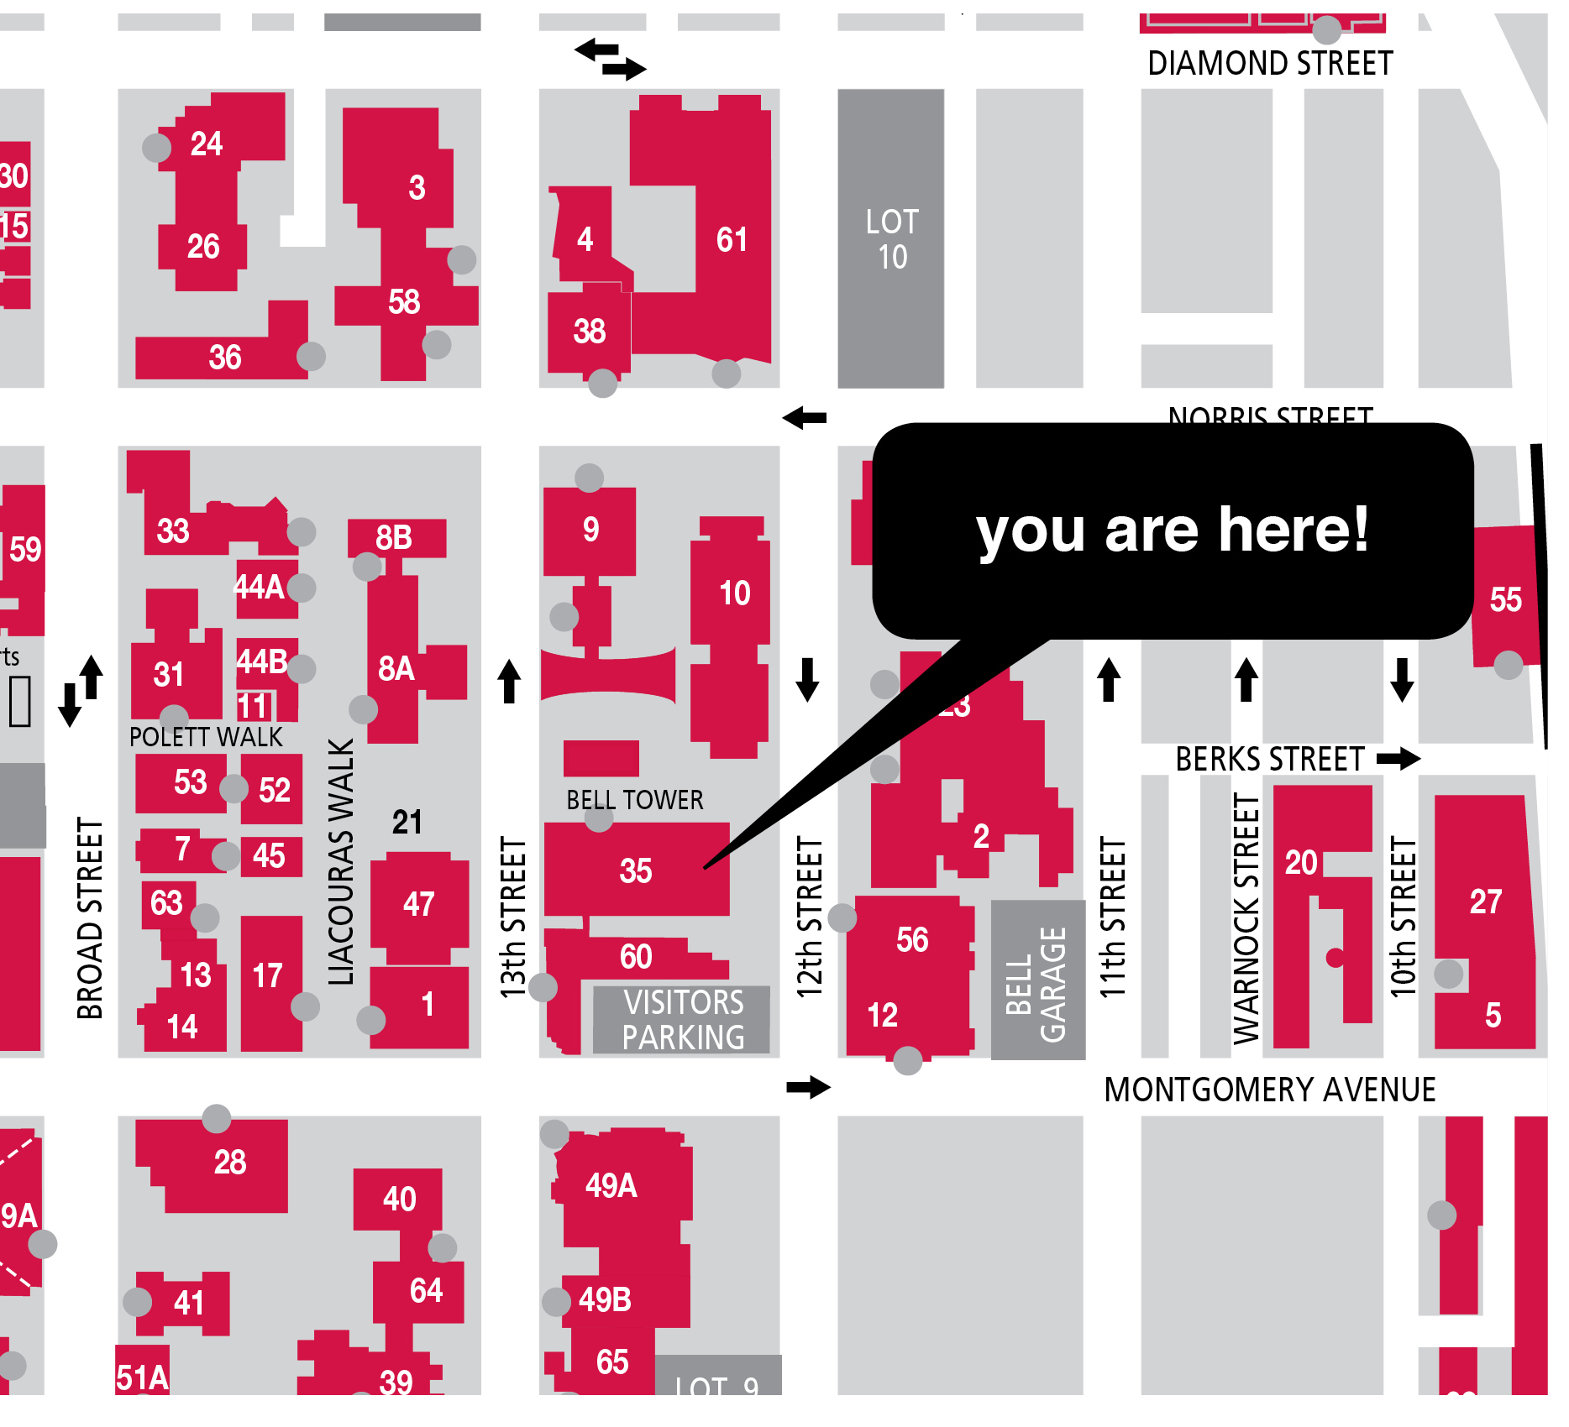
INCOL Mapping Workshop

In preparation for the Mapping Segment on 10/9, please complete the following assignment in advance of the retreat and bring it to share with your team.

Experience Mapping: Where you’ve been/Where you are/Where you want to go
A tool to understand your organization and plan for its future

This segment will introduce the concept of mapping and its application as a tool for visualizing processes and work flows, planning and improving the library experience for community members.

Overview:

map
n.
1. a. A representation, usually on a plane surface, of a region of the earth or heavens.
b. Something that suggests such a representation, as in clarity of representation.
tr.v. mapped, map·ping, maps
1. a. To make a map of.
b. To depict as if on a map: Grief was mapped on his face.
2. To explore or make a survey of (a region) for the purpose of making a map.
3. To plan or delineate, especially in detail; arrange: mapping out her future.

Traditionally, a map is a tool to help us understand our world. It is a graphic representation of relationships, qualities and characteristics, and power. It documents where we are, where we have been and where we want to go. It is a tool of exploration, understanding and control.

How can we use a map to explore, understand and control work processes, customer experiences and staff satisfaction?

This is the focus of the mapping workshop.

In planning for participation each attendee is asked to perform a few tasks in advance of the workshop.

Projects:

Participants may choose from one of the following projects and will be assigned to work with those who choose the same project:

Project 1:
SEARCH and RETRIEVE a research article assuming the role of a researcher, student or faculty member. What is the process in your library by which a community member would navigate their way to locating an article on a particular topic.

Project 2:
PLACE something on reserve assuming the role of a community member, student or faculty member. In an academic setting placing something on reserve refers to material that is reserved for a specific course. In a public setting it would refer to reserving a book for future borrowing. In either setting the user must go though a process to complete their objective. You will be mapping that process.

Instructions:

- Be the user: personally complete the task that is the focus of your project
  - Document your experience through notes, observations, photographs, video
  - Map your experience to visually convey sequence/process/time/thoughts/emotions
- Use any format or medium you like using at least 2 of the following:
- Narrative / sequential photography/diagrams/drawings/screen shots
- (Think of maps you have used. The can be simple or complex and can use different methods to convey information. A great way to understand different options is to use Google Maps to plan a trip. They give you multiple methods to understand you route using a text list, drawings/diagrams, aerial photos, street views and hybrids.)

- Observe others engaged in this task. Find out as much as possible from them.
  - Photograph/video them/the environment/the Big picture/the SMALL details
  - Interview them and write a 1 pg summary

- Bring with you: The map you create (part 1)
10-20 printed photos (for reference only - low quality prints are fine)*
1 page interview summary

